Guidelines on NCP Prevention and Control for Public Transportation

I. Personnel Management
1. Set up health reporting system. Designate personnel to record health condition of staffs and take body temperature for everybody twice a day in the morning and afternoon. Anyone who has fever, dry cough, or other symptoms, should stop working immediately and go to fever clinic at designated hospitals with face mask on.
2. Staffs should wear labor suits, disposable medical surgical masks(or masks with higher level of protection) and wash hands frequently. If conditions permit, disinfect hands with hand sanitizer.
II. Vehicle Management
1. Ventilation
Turn on the exhaust device for inner-circulated air-conditioning vehicles and open windows often for outer-circulated air-conditioning vehicles . Open windows (doors) for at least 1 hour or turn on the air conditioning for at least 15 minutes to ventilate after stopping operation every day.
2. Cleaning
Keep the carriage clean and clean up the garbage in time. Used masks shall be disposed according to the Work plan on standardizing the disposal of used masks by residents during an epidemic (interim).[Ref: Hufenleiban 2020 No.2 ].
3. Disinfection. Disinfect after daily operation hours. Increase the frequency of disinfection if necessary. People who are responsible for disinfection should wear labor suit, mask and waterproof gloves.
- Surface of objects :
Doors, steering wheels, handrails and other public parts should be wiped with disinfectant (250mg / L-500mg / L effective chlorine content), and be rinsed off after 30 minutes.
- Floor of vehicle
Floor of the vehicle should be moped by disinfectant (250mg / L-500mg / L effective chlorine content), and be rinsed off after 30 minutes.
- Knitting supplies
Keep Chair covers and other knitting supplies clean. Soak them with disinfectant (250mg/ L-500mg /L effective chlorine content ) weekly, and rinse off after 30 minutes with clear water.
III. Publicity and Education
1. Popularize knowledge of NCP prevention and control through TV on the bus.
2. Remind Passengers to wear masks, cover mouth and nose when coughing and keep vehicle clean.
3. Follow the official wechat account of <Huzhou Disease Control> and < Health Huzhou> to get the knowledge of NCP prevention and control.

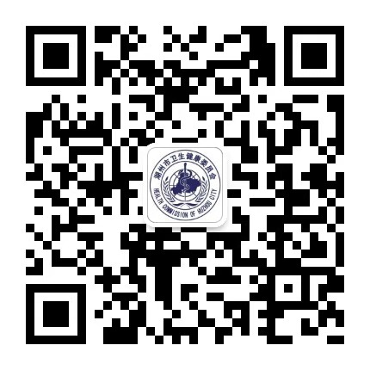
"Huzhou Disease Control" "Health Huzhou"

公共交通工具新型冠状病毒肺炎
预防控制指引
一、人员管理
（一）建立健康报告制度。落实人员每日登记职工健康状况，上下午测量体温各1次。职工有发热、干咳等症状，应停止工作并佩戴口罩至医院发热门诊就诊。
（二）工作人员穿工作衣，勤洗手，戴一次性医用外科口罩（或其他更高级别的口罩）。有条件的，使用免洗手消毒液消毒双手。
二、车辆管理
（一）通风。密闭空调车应开启排风装置；非密闭车辆应经常开窗通风。每天停止运行后，开窗（门）通风至少1个小时或采用空调强制排风至少15分钟。
（二）清洁。随时清洁车厢。使用过的口罩，按照《关于规范疫情期间居民废弃口罩处置的工作方案（暂行）》（湖分类办〔2020〕2号）处理。
（三）消毒。每日运营结束后进行消毒。必要时，增加消毒频次。消毒人员要穿工作衣，戴口罩、防水手套等。
1.物体表面：车门、方向盘、扶手等经常接触部位，可使用有效氯含量为250mg/L-500mg/L的消毒液进行喷洒或擦拭，30min后清水擦净。
2.车辆地面：车辆地面，可使用有效氯含量为250mg/L-500mg/L的消毒液拖拭，30min后清水拖净。
3.针织用品：椅套等针织用品应保持清洁，每周用有效氯含量为250mg/L-500mg/L的消毒液浸泡，30min后清水冲净。
三、健康宣教
（一）利用车载电视等宣传新型冠状病毒肺炎相关防控知识。
（二）倡导乘客佩戴口罩、遵守咳嗽礼仪、注意保持车辆卫生。
（三）关注“湖州疾控”和“健康湖州发布”微信公众号，获取疾病防控知识。
湖州疾控 健康湖州发布

